Task 1:

#include<iostream>

using namespace std;

struct bpdata

{

char name[90];

int runs;

int hit;

};

int main()

{

int n = 0,num=0,temp=0;

bpdata \*d=new bpdata[3];

bpdata input();

{

for (int i = 0; i < 3; i++)

{

cout << "enter " << i << " student name :";

cin >> (d + i)->name;

cout << "enter " << i << " student runs :";

cin >> (d + i)->runs;

cout << "enter " << i << " student hit :";

cin >> (d + i)->hit;

}

}

bpdata output();

{

for (int i = 0; i < 3; i++)

{

cout << "\nthe data of " << i << " student is : \n";

cout << (d + i)->name << endl;

cout << (d + i)->runs << endl;

cout << (d + i)->hit << endl;

}

}

do

{

cout << "\n if you want to search the data of student press 1 : ";

cin >> n;

switch (n)

{

case 1:

{

bpdata search();

{

cout << "enter student no. b/w 0-2: ";

cin >> num;

switch (num)

{

case 0:

{

bpdata update();

{

cout << "enter 0" << " student name :";

cin >> (d + 0)->name;

cout << "enter 0" << " student runs :";

cin >> (d + 0)->runs;

cout << "enter 0" << " student hit :";

cin >> (d + 0)->hit;

}

break;

}

case 1:

{

bpdata update();

{

cout << "enter 1" << " student name :";

cin >> (d + 1)->name;

cout << "enter 1" << " student runs :";

cin >> (d + 1)->runs;

cout << "enter 1" << " student hit :";

cin >> (d + 1)->hit;

}

break;

}

case 2:

{

bpdata update();

{

cout << "enter 2" << " student name :";

cin >> (d + 2)->name;

cout << "enter 2" << " student runs :";

cin >> (d + 2)->runs;

cout << "enter 2" << " student hit :";

cin >> (d + 2)->hit;

break;

}

}

default:

cout << "wrong input";

break;

}

}

}

default:

cout << "wrong input";

break;

}

cout << "\nif you want to re-enter student info press 2: ";

cin >> temp;

} while (temp==2);

bpdata output();

{

for (int i = 0; i < 3; i++)

{

cout << "\nthe data of " << i << " student is : \n";

cout << (d + i)->name << endl;

cout << (d + i)->runs << endl;

cout << (d + i)->hit << endl;

}

}

delete[] d;

}

//we can do it as:

int tempo = 0,hits=0,run=0;

char n[90];

cout << "if you want to search by name press 1\n by runs than press 2\n by hits press 3";

cin >> tempo;

switch (tempo)

{

case 1:

{

cout << "enter name: ";

for (int i = 0; i < 90; i++)

{

cin >> n[i];

}

for (int i = 0; i <3; i++)

{

for (int j = 0; j < (sizeof(ch[90]) / sizeof(ch[0])); j++)

{

}

if (ch[j] == n[j])

{

num = i;

update();

}

}

}

break;

}

case 2:

{

cout << "enter runs";

cin >> run;

for (int i = 0; i < 3; i++)

{

if (run == (d + i)->runs)

{

//func update and search is called...

}

}

break;

}

case 3:

{

cout << "enter hits";

cin >> hits;

for (int i = 0; i < 3; i++)

{

if (hits == (d + i)->hit)

{

//func update and search is called...

}

}

break;

}

default:

cout << "wrong input";

break;

}

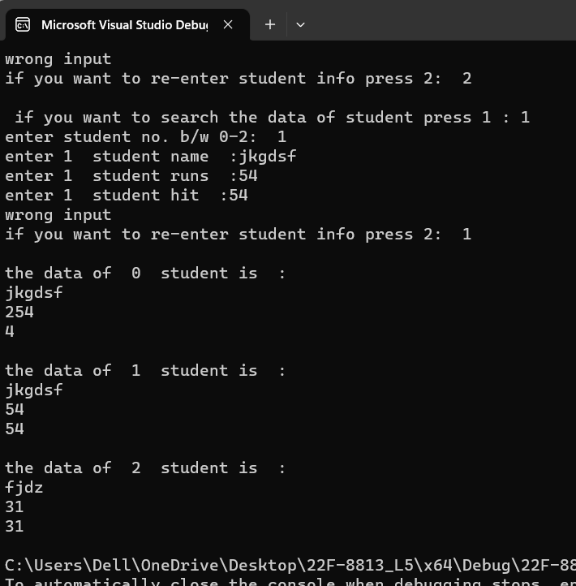

Task 2:

#include<iostream>

using namespace std;

struct address

{

int house;

int street;

char cityname[90];

char province[90];

};

struct student

{

char nameofstudent[6];

address ad[10] = {0};

int age;

float GPA;

};

void main()

{

int num = 0;

student st[90] = {0};

cout << "please enter student numbers : ";

cin >> num;

for (int i = 0; i < num; i++)

{

cout << "enter name of " << i << " student :";

cin >> st[i].nameofstudent;

cout << "enter address of house,street,cityname,province " << i << " student with pressing enter in this sequence :";

cin >> st[i].ad[i].house>> st[i].ad[i].street>> st[i].ad[i].cityname>> st[i].ad[i].province;

cout << "enter age of " << i << " student: ";

cin >> st[i].age;

cout << "enter GPA of " << i << " student: ";

cin >> st[i].GPA;

}

for (int i = 0; i < num; i++)

{

cout <<"name of student "<<i<<" is :" << st[i].nameofstudent << endl;

cout <<"house # " << st[i].ad[i].house << ", street# " << st[i].ad[i].street<<" , cityname " << st[i].ad[i].cityname <<" , province name " << st[i].ad[i].province << endl;

cout << "age of student " << i << " is :" <<st[i].age<<endl;

cout << "GPA of student " << i << " is :" << st[i].GPA<<endl;

}

system("pause");

}

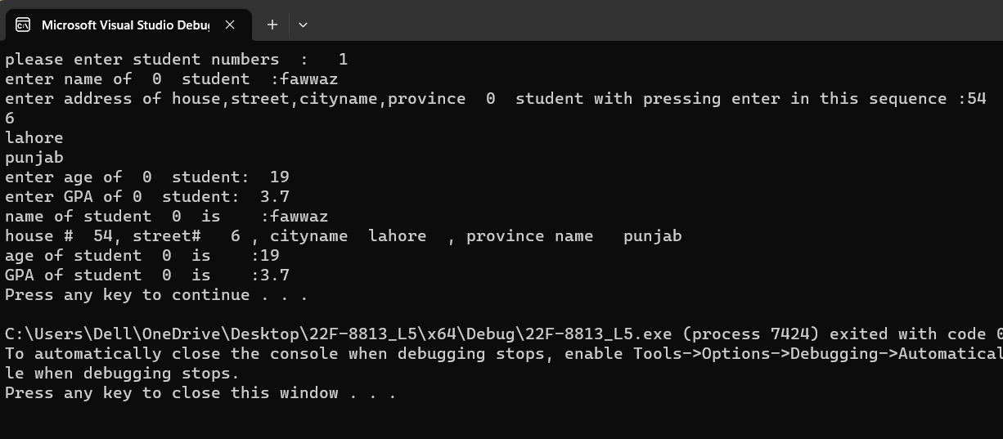

Task 3:

#include<iostream>

using namespace std;

enum week

{

les,

monday = 1,

tuesday = 2,

wednesday=3,

thursday=4,

friday=5,

saturday=6,

sunday=7,

high=999999

};

int main()

{

week today;

cout << "enter today : ";

int num = 0;

today=friday;

num = today;

if (num < 0)

{

today=les;

num = today;

cout << num;

}

else if (num > 7)

{

today = high;

num = today;

cout << num;

}

cout << "the value of today is : " << num << endl;

num = today - 1;

cout << "the value of yesterday is : " << num << endl;

num = today + 1;

cout << "the value of tomorrow is : " << num << endl;

}

